Narrative Essay Fall 2019
U.S. History Grade 8 and American Civics Grade 7
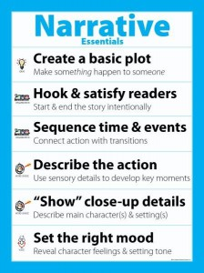
A narrative essay is writing that tells a story about a personal experience. Choose a social studies-based personal experience and compose a 5 paragraph essay which narrates your experience.
- There is a sort of sequencing of events as you tell your narrative story

Choose from one of these topics:
- JJH Walk For Water Volunteer Experience Spring 2019
- Summer School experience
- A place to which you traveled as a vacation experience
- An important economic decision that you made within the past year
- Any type of museum experience that you had within the recent past
- The process that you underwent to become a College Prep student
- Any interaction that you had with the police, either positive or negative.
- Any type of Jennings School District extra-curricular activity of which you are a part like band, choir, Waltzing Warriors, sports/clubs
- Your Choice……

INSTRUCTIONS:
- Choose a topic
- Use the 5-paragraph essay graphic organizer to compose a rough draft
- Make sure you have a topic sentence and hook in your first paragraph
- Final copy will need a complete heading, title, picture, and use font size 14

